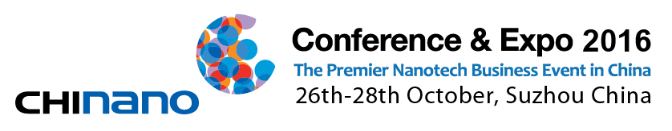CHInano 2016 Conference & Expo

CONTRACT

**1、 Basic information of exhibitors**

Company：

Address：

Contact： Position：

Mob: Tel：

Fax： Email：

Website：

**2、 Application for exposition**

Standard booth □ Bare floor indoors □

Length m ×depth m = m2 Applying booth No.：

Main products on display：

Exhibits its own □ need to help transport links□

Booth cost USD：

English and Chinese introduction of the company less than 200 words should be sent to organizing committee by exhibitors after signing the contract by e-mail

**3、 Application for forum**

Topic of forum speech：

Name of Speakers： Position：

Time ：

Language used in speech:

Chinese □ English □

Costs USD：

Free meeting rooms, photographic instruments, audio equipment, etc. are provided by Organizing Committee, Chinese or English are required for speakers(with translation to other languages).

**4、Application for ADS**

Front cover□ Back cover□ Back Cover□ Inside Front Cover□

The First Page□ Across colorful page□ Inside colorful page□ Black and white page□ Flying balloons□ The inflating arched door□ Entrance Ticket□ Badges□ Badge belts□ Scroll□ The flag□ Design your own ads□ Need Organizing committee to design the advertising□

Costs USD：

Costs are extra if Organizing Committee are needed for designing. Content for advertising should be put in to Organizing Committee by e-mail or fax before Oct 1st, 2016.

**5、Total costs USD：**

50% of the total costs should be remitted into the designated account of the Organizing Committee in 7 working days, the rest should be remitted before OCT 1st.The Organizing committee have the right to cancel your booth if the advance payment exceeds the time limit. (Please fax the remittances document to the organizing committee in time in order to determine the boot

**6、Contact：**

Nanotech Industry Innovation&Development Center

Contact person：Nick Wan

Mobile：13584824068

Fax：0512-66680999

Email：wancd@sipac.gov.cn

Address: 9th floor, No.999, Suzhou modern Avenue, Suzhou industrial Park, Suzhou, China, 215028

**We agree with all the content in the application form and the Expo is in charge of Expo Organizing Committee. This agreement is valid since the signing day.**

**Principals signature：**

**（Please with official seals）**

**Date:**